**Project 2:**

**(II)**

**1) Write a pig script to find no of complaints which got timely response**

**Commands:**

**C:\Users\613000\Desktop\pro2acmd1.PNG**

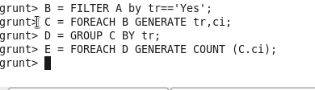

**Output:**

**C:\Users\613000\Desktop\pro2aout.PNG**

**2) Write a pig script to find no of complaints where consumer forum forwarded the complaint same day they received to respective company**

**Commands:**

**C:\Users\613000\Desktop\pro2acmd1.PNG**

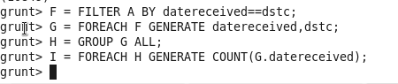

**Output:**

**C:\Users\613000\Desktop\pro2bout.PNG**

**3) Write a pig script to find list of companies topping in complaint chart (companies with maximum number of complaints)**

**Commands:**

**C:\Users\613000\Desktop\pro2acmd1.PNG**

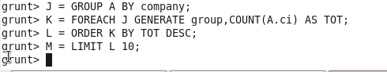

**Output:**

**02**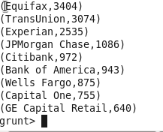

**4) Write a pig script to find no of complaints filed with product type has "Debt collection" for the year 2015**

**Commands:**

**C:\Users\613000\Desktop\pro2acmd1.PNG**

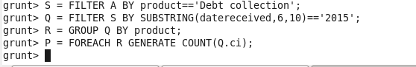

**Output:**

**C:\Users\613000\Desktop\pro2dout.PNG**

**I.**

**1. Write a mapreduce program to remove commas present inside the double quotes**



